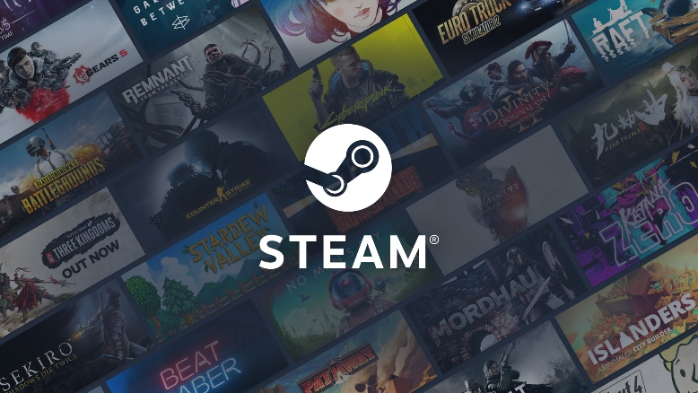Stciking to the video game industry, I brought to you the business model canvas of Steam. Steam is a video game platform that allows it’s users to watch others play or purchase and play games on your own. Steam is like a digital marketplace combined with streaming service and is available on every computer platform. Steam is owned by Valve Corporation, which is a game developer and publisher company.

First let’s talk about the costumer segments. The main costumer base is the gamers. The only thing you need is the game specific hardware requirement.

Their value propositions are simple. They made a platform which is easy to use. The platform is completely free to use, you only have to pay for the games. You can level up your account by buying and playing games so there is a competition factor as well. In the end Steam is like a library for all the games you own.

You can download Steam from the following link by clicking on the Install Steam button: <https://store.steampowered.com> . The webpage also gives a great image about what Steam’s marketplace really is like. But further more Steam is the channel itself.

Let’s look at the costumer relationships. It’s automated, so there is no human interaction needed. It’s also varying, not every game is avaiable there but they always present us new games day by day. So maybe if I want to play League of Legends I have to use the Riot Client or the Epic Games’s platform which is Steam’s biggest competitor but if I want to play Life is Strange but I don’t have the remastered version yet, then I can buy a digital copy and download it right away.

A few quick words about revenue streams. They have an online payment system so you don’t have to visit a store nor can you pay with cash cause you get the prudct immidiately so you can’t give it to the delivery guys. They came up with the Steam card idea which can be bought from IT shops and then people with no creditcards could upload money to their virtual Steam wallet.

Their key resources are the first-party game titles comming from Valve and their employees. We can say that the employee knowledge is the main source.

The key activities are clear. In addition to those mentioned above they also manage digital rights. The crucial points are the user-friendly UI and the good network connection.

Game Developers and Studios are their key partners. They have regularly 35-40 million active user per day.

And last but not least the cost structure. They don’t ask for extra money for downloading games. They get their money after purchases both hardware and software, every week they present new sales, and there is also the Steam wallet card. Not long ago they started a new project called Steam PC Café Program which helps with licensing in net cafes and gaming clubs.